**North South University Examination Book**

**Department of Electrical & Computer Engineering**

**Quiz Mid Term1 Mid Term2 Final Exam**



**Semester: Samin Yasar**

**Course: CSE115 Section: 14 Course Instructor’s Initial: TNS1**

**Student Name: Samin Yasar ID No: 2011279642**

**Student Signature: Samin Yasar Date: 3/ 6/ 2020**

|  |
| --- |
| **...................................... ………………**  **Examiner’s Signature Date** |
|  |

|  |
| --- |
| Instructions:   1. Do not use any unfair means. If you cheat in any form or do not follow faculty instructions your examination will be cancelled. 2. You must submit the assessment within the allowed timeframe. |

**CSE 115: Programming Language I**

**Spring 2020**

Submission deadline: 04/06/2020

(

FIXED

)

(

You must answer right under the question

. However, you can add extra page

)



|  |
| --- |
| **Please read the instructions before you proceed:**   * **This is an open book assessment.** * **There are 3 sections for this final assessment.** * **You may use computer to check your program runs correctly or not. However, plagiarism is strictly prohibited. We will use plagiarism checker to ensure that every one don't copy from some others.** * **If any one cheats in this assessment, he or she may be marked as zero. Moreover, you will be scored to zero, if you are late in submitting the assessment.** |

# Section 1



1. **Write a program in recursion that computes the sum of the**  **series: 12 + 52 + 62 + 112 + 172 + 282 +… …. + n2 (n is an input)**

Answer to the question no:1

Answer:

#include<stdio.h>

int n;

int fibonacci(int a, int b);

int main()

{

int a = 1, b= 5,temp;

printf(" enter the terms : ");

scanf("%d", &n);

printf(" The summation is:\n");

temp=1+fibonacci(a, b);

printf("%d",temp);

}

int fibonacci(int a, int b)

{

int i = 2,sum= 25 ;

int c;

if (i == n)

return 0;

else

{

c= a + b;

a = b;

b = c;

sum=sum + pow(c,2);

i++;

fibonacci(a,b);

}

return (sum);

}

1. **Write a program to search for a pattern in a given string. For Example-**

**Input: src[] – “How are you”**

**Pattern: pat[] - “are”**

**Output: Pattern is found**

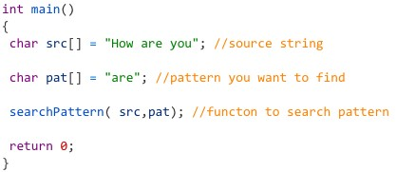

Answer to the question no: 2

Answer:

#include <stdio.h>

int main()

{

char s[80], s2[20];

int a=0,b=0,i,j,t;

printf("enter your desired string : ");

fgets(s, sizeof s, stdin);

printf("enter the substring you want to search : ");

fgets(s2, sizeof s2, stdin);

while (s[a]!='\0')

a++;

a--;

while (s2[b]!='\0')

b++;

b--;

for(i=0;i<=a-b;i++)

{

for(j=i;j<i+b;j++)

{

t=1;

if (s[j]!=s2[j-i])

{

t=0;

break;

}

}

if (t==1)

break;

}

if (t==1)

printf("The substring you want is in the string.\n\n");

else

printf("The substring you want is not in the string. \n\n");

}

1. **Write a user-defined function (int sumOfDigits(int x)), which returns the**

**sum of digits of the positive integer x. For example, when called with the**

**parameter 12345, this function returns 15.**

**Answer to the question no: 3**

**Answer:**

**#include<stdio.h>**

**int sumOfDigits(int x)**

**{**

**int summation = 0;**

**while (x != 0)**

**{**

**summation = summation + x % 10;**

**x = x/10;**

**}**

**return summation;**

**}**

**int main()**

**{**

**int n;**

**printf("Enter the number: ");**

**scanf("%d", &n);**

**printf("the Sum:\n %d", sumOfDigits(n));**

**return 0;**

**}**

# Section 2

1. **Write a program to calculate the area of the polygon using the structure** **(declaration for structure is given below), An example to calculate the area**  **is given below also-**

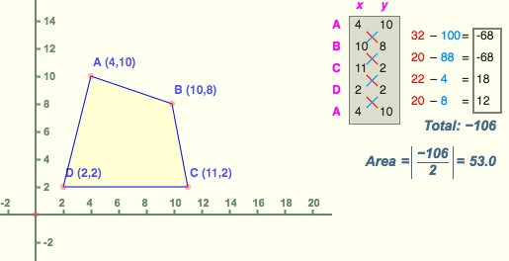

**Answer to the question no: 1**

**Answer:**

#include <stdio.h>

struct Point

{

int p,q;

};

int main()

{

printf ("How many points are there?\n");

int n;

scanf ("%d",&n);

struct Point a[n];

int i;

for (i=0;i<n;i++)

{

printf ("input the points\n",i+1);

printf ("X%d: ",i+1);

scanf ("%d",&a[i].p);

printf ("Y%d: ",i+1);

scanf ("%d",&a[i].q);

printf ("(%d,%d)\n", a[i].p, a[i].q);

}

int t= 0, possitive= 0, negative= 0;

for(i=0;i<n-1;i++){

possitive+= a[i].p * a[i+1].q;

}

for(i=0;i<n-1;i++){

negative+= a[i].q * a[i+1].p;

}

possitive+= a[n-1].p * a[0].q;

negative+= a[n-1].q * a[0].p;

t= possitive-negative;

double area= t/2.0;

if(area < 0)

printf("The area is= %lf\n", -area);

else

printf("The area is= %lf\n", area);

return 0;

}

1. **Write a C program to print the prime numbers between 2 to 1000 in an I/O**

**File.**

**Answer to the question no: 2**

**Answer:**

#include <stdio.h>

#include <string.h>

int n;

int num[100000],primes[100000];

int PrimeNumbers()

{

int cnt=0,i,j,k;

for (i=2;i<=10000 ;i++ )

{

if(num[i]==1){

continue;

}

k=2;

for (j=i*2;j<100000 ;j=i*k )

{

num[j]=1;

k++;

}

}

for (i=0;i<10000 ;i++ )

{

if(num[i]==0){

primes[cnt++]=i;

}

}

for (i=2;i<1000 ;i++ )

{

printf("%d\n",primes[i]);

}

}

int main()

{

PrimeNumbers();

return 0;

}

1. **Write a function (using a pointer parameter) that reverses the elements of**  **a given array.**

Input: Input array elements: 10 20 30 40 50 60 70 80 90 100

Output: Reversed array: 100 90 80 70 60 50 40 30 20 10

**Answer to the question no: 3**

**Answer:**

**#include <stdio.h>**

**int main()**

**{**

**int *a,n,i,j,t;**

**printf ("Enter the size of the array:");**

**scanf ("%d", &n);**

**a= calloc(sizeof(int), n);**

**printf ("Enter %d Elements:", n);**

**for (i=0;i<n;i++)**

**{**

**scanf ("%d",a+i);**

**}**

**for (i=0,j=n-1;i<j;i++,j--)**

**{**

**t=*(a+i);**

**\*(a+i)=*(a+j);**

**\*(a+j)=t;**

**}**

**printf ("Reversed array:\n");**

**for(i=0;i<n;i++)**

**{**

**printf("%d ",*(a+i));**

**}**

**return 0;**

**}**

# Section 3

1. **Write a program that reads three integers from user (a, b, c) and then, write a program**  **in C to find the value of x from the equation of (ax2 + bx + c = 0) (Please Use User-Defined**

**Function).**

Answer to the question no: 1

Answer:

#include <stdio.h>

#include <math.h>

int main()

{

double a, b, c, d, X1, X2, rP, iP;

printf("Enter the value of a");

scanf("%lf", &a);

printf("Enter the value of b");

scanf("%lf", &b);

printf("Enter the value of c");

scanf("%lf", &c);

d = b * b - 4 * a * c;

if (d > 0)

{

X1 = (-b + sqrt(d)) / (2 * a);

X2 = (-b - sqrt(d)) / (2 * a);

printf("X1 = %.2lf and X2 = %.2lf", X1, X2);

}

else if (d == 0)

{

X1 = X2 = -b / (2 * a);

printf("X1 = X2 = %.2lf;", X1);

}

else

{

rP = -b / (2 * a);

iP = sqrt(-d) / (2 * a);

printf("X1 = %.2lf+%.2lfi and X2 = %.2f-%.2fi", rP, iP, rP, iP);

}

return 0;

}

1. **Write a C program that will enter n elements in a one-dimensional array and print those array elements, which are prime numbers. Memory must be allocated using**  **malloc(), released using free() and total number of elements will be a user input.**

**Answer to the question no: 2**

**Answer:**

#include<stdio.h>

int main()

{

int a[10],n,i,j,k=0, number[10],d=0;

printf("Enter Limit of the array: ");

scanf("%d",&n);

for(i=0;i<n;i++)

scanf("%d",&a[i]);

for(i=0;i<n;i++)

{

k=0;

for(j=2;j<a[i];j++)

{

if(a[i]%j==0)

{

k=1;

break;

}

}

if(k==0)

{

number[d]=a[i];

d++;

}

}

printf(" The prime numbers are:");

for(i=0;i<d;i++)

{

printf("\t%d", number[i]);

}

return 0;

}

1. **Write a program to read a number n from user, calculate the sum of the following series up to n-th term, and print the sum at the end: 12 + 22** + **112** + **362** + **852** … **(2 marks bonus for writing the answer in recursion)**

Answer to the question no: 3

Answer:

#include <stdio.h>

#include <string.h>

int n;

int recuFunc(int S,int B)

{

if(S==n)

{

return (B+((2*(S-1)-1)*(2*(S-1)-1)))*(B+((2*(S-1)-1)*(2*(S-1)-1)));

}

else if(S==1)

{

return 1*1+recuFunc(S+1,1);

}

else

{

return (B+((2*(S-1)-1)*(2*(S-1)-1)))*(B+((2*(S-1)-1)*(2*(S-1)-1)))+recuFunc(S+1,(B+((2*(S-1)-1)*(2*(S-1)-1))));

}

}

int main()

{

printf("Enter the limit: ");

scanf("%d",&n);

printf("%d",recuFunc(1,0));

return 0;

}

1. **Write a program that reads an n*n matrix from user (n is an input) and prints the sum of elements in its upper left triangle and in its diagonal. For e.g. for the following matrix, the program will print 93. (Diagonal and upper left triangle elements are the bold ones).**

𝟏 𝟐 𝟑 𝟒 𝟓 𝟔

𝟕 𝟖 𝟗 𝟎 𝟏 2

𝐴=  𝟑𝟗 𝟒𝟎 𝟓𝟏 𝟔2 73 48

𝟓 𝟔 7 3 4 5 (𝟖 9 0 8 7 6)

**Answer to the question no: 4**

**Answer:**

**#include<stdio.h>**

**int main()**

**{**

**int i, j, n, Sum=0;**

**printf("Enter the size of matrix ");**

**scanf("%d", &n);**

**int matrix[n][n];**

**printf("Enter the value:");**

**for(i=0; i<n; i++)**

**{**

**for(j=0; j<n; j++)**

**{**

**printf("\nmatrix[%d][%d] = ", i, j);**

**scanf(" %d", &matrix[i][j]);**

**}**

**}**

**printf("\nmatrix = \n");**

**for(i=0; i<n; i++)**

**{**

**for(j=0; j<n; j++)**

**{**

**printf(" %d", matrix[i] [j]);**

**}**

**printf("\n");**

**}**

**for(i=0; i<=n; i++)**

**{**

**for(j=n; j>=0; j--)**

**{**

**if(i<=j)**

**{**

**Sum+= matrix[i][j];**

**}**

**}**

**}**

**printf("Sum= %d", Sum);**

**}**

1. **Draw the “Flowchart” for your program written in question 4.**

**Answer to the question no: 5**

Answer: Flowchart of the program of number 4 -

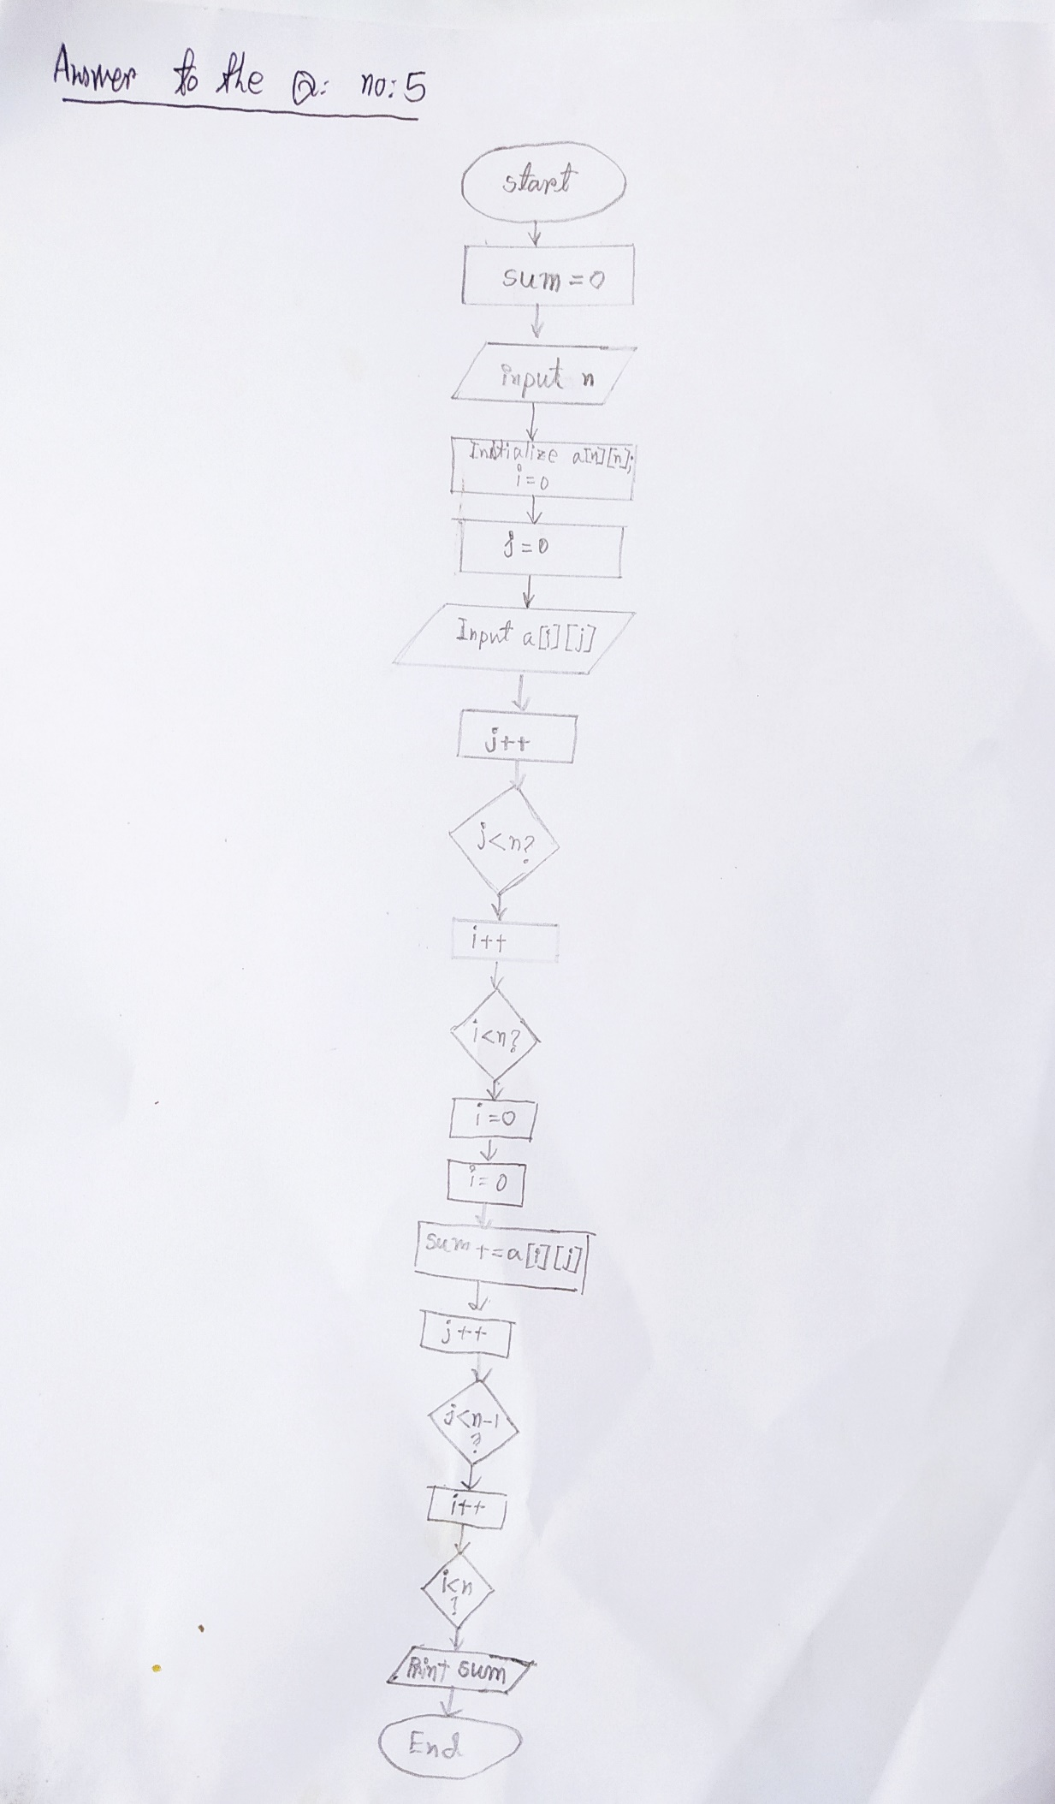

1. **Write a program that prints the sum of first n elements in the series: 7 + 21 + 35 + 49 +….**

**(Those numbers are divisible by 7 but not divisible by 14). For e.g., for n = 3 it prints 63. (Must**

**Use A Recursive Function)**

**Answer to the question no: 6**

**Answer:**

**#include <stdio.h>**

**#include <string.h>**

**int n;**

**int recFunc(int a)**

**{**

**if(a==1)**

**{**

**return 7;**

**}**

**else**

**{**

**return 7*(2*a-1)+recFunc(a-1);**

**}**

**}**

**int main()**

**{**

**printf ("Enter the limit: ");**

**scanf("%d",&n);**

**printf("%d",recFunc(n));**

**return 0;**

**}**

1. **Suppose you have a structure of Bangladesh Cricket Players containing below records. Moreover, the players.txt file is given for the record of each player.**

|  |  |  |  |
| --- | --- | --- | --- |
| **Player Name** | **Year of 1st Match** | **Highest Score** | **Total Wicket** |
| Abdur Razzak | 2004 | 53 | 207 |
| Mushfiqur Rahim | 2006 | 144 | 0 |
| Shakib Al Hasan | 2006 | 134 | 260 |
| Aftab Ahmed | 2004 | 92 | 12 |
| Mashrafe Mortaza | 2001 | 51 | 265 |

* 1. **Now, declare a structure called PlayerList to access the beforehand data of the players.**

**Answer:**

**struct PlayerList**

**{**

**char Name[1000];**

**int Year,HighestScore,Wickets;**

**};**

* 1. **Now write a program to print the following output in your console window reading through the records from players.txt file.**

**[Hint: you need to rearrange the PlayerList structure array based on their Highest Score]**

|  |  |  |  |
| --- | --- | --- | --- |
| **Player Name** | **Year of 1st Match** | **Highest Score** | **Total Wicket** |
| Mushfiqur Rahim | 2006 | 144 | 0 |
| Shakib Al Hasan | 2006 | 134 | 260 |
| Aftab Ahmed | 2004 | 92 | 12 |
| Abdur Razzak | 2004 | 53 | 207 |
| Mashrafe Mortaza | 2001 | 51 | 265 |

Answering guideline:

* Print this file and write your answer on the printed paper, scan the answer script and submit the scanned version. Add extra pages when the printed space is not sufficient.
* You may consult textbooks and online sources. However, for online sources, make sure they are authentic sources, such as they are from journal papers, conference papers or technical notes from well-known companies (GE, ABB, etc.). If you give online references, please mention the sources.
* It is not allowed to consult with any person who has knowledge of this subject, including other students of this course. You may ask question to the instructor if you do not understand the question, but not more than that. All solutions have to be your own work.
* Plagiarism checker will be used to verify that someone cheats or not.

. Please add short explanation of each program where applicable in questions. Careful that it carries marks.

CODE OF HONOR PLEDGE

I pledge on my honor that I have not given or received any unauthorized assistance on this assignment.

Signature:_Samin _Yasar__

Date :____________________________

————————————————————